**Methanol Synthesis**

Harsh Nirmal

220431

Aim

*Determining the unknown molar flow rates of various streams using mass balance equations in the process flow diagram of production of methanol from CO2 and H2.*

Method

*Methanol is widely used in the chemical industry to produce formaldehyde, acetic acid, olefins, gasoline, etc. Most of the methanol is industrially produced by catalytically converting synthesis gas, which is a mixture of CO2, CO, and H2 derived from natural gas.* *Methanol is a promising energy carrier because, as a liquid, it is easier to store than hydrogen and natural gas. Its energy density is, however, lower than methane, per kg. Its combustion energy density is 15.6 MJ/L , whereas that of ethanol is 24 and gasoline is 33 MJ/L.*

*Further advantages for methanol is its ready biodegradability and low environmental toxicity. It does not persist in either aerobic (oxygen-present) or anaerobic (oxygen-absent) environments.*

*Alternatively, methanol can be produced by the direct hydrogenation of CO2:*

*CO2 + 3H2 ⇔ CH3OH + H2O*

*A process flow diagram is shown in Figure 1. The temperature and pressure of the inlet CO2 and H2 streams are 25 °C and 1 bar, respectively. The two gases are compressed to 78 bar by a series of compressors with coolers. The two streams are mixed with a recycle stream, heated to 210°C, and fed to a reactor. The high-pressure gases leaving the reactor are throttled through a valve to reduce the stream pressure to 72 bar and cooled to 40 °C. The stream then enters a flash drum, where a large fraction of unreacted CO2 and H2 in the vapor phase is separated from CH3OH and H2O in the liquid phase. A fraction of the vapor stream is purged, and the remaining is recycled to be mixed with the fresh stream of CO2 and H2. The pressure of the liquid stream from the flash drum is reduced to 1 bar, and another flash drum is employed to separate CO2 and H2. The liquid stream primarily containsCH3OH and H2O, which are separated using a distillation column. CH3OH is obtained in the overhead stream, andH2O in the bottom stream.*

*The approach involves utilizing mass balance equations, performing degree of freedom analysis, and employing Gauss Elimination for validation.*

*The detailed process flow diagram is as follows:*

*A simpler and less complicated process flow diagram which we will be following for our calculations is as follows:*

*The mass balance equation represents the principle of conservation of mass. The sum of the flow rates of the top and bottom products should be equal to the inlet flow rate, ensuring that no mass is lost or gained during the process. The variables involved in the problem are the molar flow rates of CO2, H2, CH3OH, and H2O in streams 3,4,5 and 6.*

*Table given in the problem statement: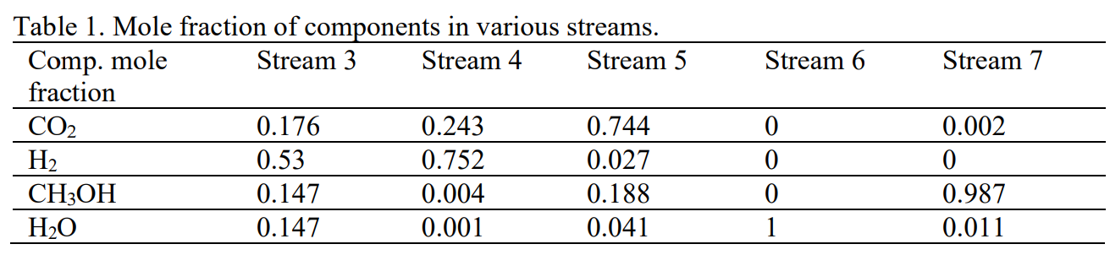*

Degree of Freedom Analysis:

The degree of freedom analysis is performed by counting the number of unknowns and equations in the system.

*In the problem statement, there are 4 components:*

*CO2, H2, CH3OH, and H2O.*

*Additionally, there are 4 streams: 3, 4, 5, and 6.*

*DOF=Unknowns(variables)-Independent Equations*

*Since for every stream the data is provided and thus using conservation of mass we can find out the unknown mass flow rates of the respected streams.*

Results and Analysis:

*Used linsolve () and backslash (\) functions to solve this problem statement to find out various mass flow rates involved in the streams of methanol production using MATLAB.*

*The results are:*

*Molar flow rate of stream3 is 6163.5 kmol/hr.*

*Molar flow rate of stream4 is 4342.6 kmol/hr.*

*Molar flow rate of stream5 is 37.3 kmol/hr.*

*Molar flow rate of stream6 is 890.3 kmol/hr.*

Conclusions:

*In this lab session, we used mass balance equations to estimate the molar flow rates of different streams in a CO2 and H2 methanol synthesis process. The equations were numerically solved in MATLAB, and the Gauss Elimination method was used to confirm the outcomes. We discovered that streams 3, 4, 5, and 6 had respective molar flow rates of 6163.5 kmol/hr, 4342.6 kmol/hr, 37.3 kmol/hr, and 890.3 kmol/hr. The analysis proved that the MATLAB and Gauss Elimination results agreed with each other. The result is that the linear systems of equations can be solved with the help of MATLAB and Gauss Elimination, and the mass balance equations can be utilized to determine the molar flow rates of various streams in a methanol production process.*

Appendix:

%% Method 1: Using linsolve

% Coefficient matrix representing mole fractions of components (CO2, H2, CH3OH, H2O)

% in Streams 3, 4, 5, and 6

A = [0.176 0.243 0.744 0;

0.53 0.752 0.027 0;

0.147 0.004 0.188 0;

0.147 0.001 0.041 1];

% Right-hand side vector representing mole fractions in Stream 7 multiplied by the total molar flow rate of Stream 7 (893.263 kmol)

b = [893.263 * 0.002;

893.263 * 0;

893.263 * 0.987;

893.263 * 0.011];

% Solving the system of linear equations using linsolve

% The linsolve function in MATLAB is used to solve a system of linear equations.

% Here A is the coefficient matrix and B is the right-hand side vector. The function returns the solution vector X that satisfies AX = B

Ans = linsolve(A, b);

Ans % Display the solution vector U

%% Method 2: Using \

% Solve the system of linear equations using the backslash (\) operator

% The backslash(\) operator in MATLAB is used to solve a system of linear equations of the form Ax = B. It is used to calculate the left division between two matrices.

Augment = A\b;

Augment

%% Validating the results using Gauss Elimination

A=[0.176 0.243 0.744 0 ;

0.53 0.752 0.027 0 ;

0.147 0.004 0.188 0 ;

0.147 0.001 0.041 1];

b=[893.263*0.002;

893.263*0;

893.263*0.987;

893.263*0.011];

% A is the matrix for mole fractions of components (CO2,H2,CH3OH and H2O) in Stream 3,4,5 and 6

% B is the matrix for mole fractions of components in stream 7 multiplied with the total molar flow rate of stream 7 which is given to be 893.263kmol\

n=length(b);

% Forward elimination with partial pivoting

for k = 1:n-1

% Find the row index with the largest absolute value in the column

[~, max_row] = max(abs(A(k:n, k)));

max_row = max_row + k - 1; % Adjust the index to the global row

% Swap rows in matrix A and vector b for partial pivoting

A([k, max_row], :) = A([max_row, k], :);

b([k, max_row]) = b([max_row, k]);

% Loop through rows below the pivot (k)

for i = k+1:n

% Calculate the multiplier to eliminate A(i,k)

m = A(i,k) / A(k,k);

% Loop through columns to the right of the pivot (k)

for j = k+1:n

% Update the elements of the current row of A

A(i,j) = A(i,j) - m * A(k,j);

end

% Update the elements of the right-hand side vector b

b(i) = b(i) - m * b(k);

end

end

% Backward substitution

% Calculate the last solution component

Sol(n) = b(n) / A(n,n);

% Loop through rows in reverse order

for i = n-1:-1:1

% Initialize a sum with the right-hand side value

Sum = b(i);

% Loop through columns to the right of the pivot (i)

for j = i+1:n

% Subtract contributions from A and the solution vector Sol

Sum = Sum - A(i,j) * Sol(j);

end

% Calculate the current solution component

Sol(i) = Sum / A(i,i);

end

Sol %Solution vector